5th October 2006

Dear Therfield parents and carers

We attach a letter to you all from Mr Graham Tuck in which he announces his resignation as Headteacher of Therfield School with effect from January 2007. The Governing Body has reluctantly accepted his resignation and is very pleased that he is moving on to such a prestigious role within education.

We are, of course, very sad to see Mr Tuck leave and are extremely appreciative of his inspirational leadership over the five years he has been at Therfield. We have had some notable results in terms of academic success, recognition from OfSTED as being a ‘very good school’ and the award of Sport Specialist status.

Governors now have the responsibility, with assistance from the Local Authority, in selecting and appointing the next headteacher. We will keep you informed of our progress via the School Newsletter and we expect to make an appointment in the current school year.

In the interim we have appointed Mrs Susan Willman as Acting Headteacher and Mr Steve Hill as Acting Deputy Headteacher. Mrs Willman has six years experience here as our Deputy Headteacher and the Governing Body is looking forward to working with her and the Leadership team to ensure that the individual educational needs of your children continue to be fully met.

Yours sincerely
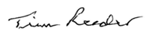
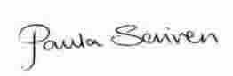

Paula Scriven and Tim Reeder
Co Chairs of Governors, Therfield School

