5th October 2006

Dear Therfield staff

As you know, Graham Tuck has tendered his resignation to Governors as Headteacher of Therfield School with effect from January 2007.

The purpose of this letter is twofold; to let you see the start of our wider communication process and the steps we will be taking to appoint a new headteacher. We attach the letters to the school community from Graham and ourselves which acknowledges his significant contributions over the last five years.

A selection panel of Governors has been delegated by the Governing Body to take the process forward. We are planning to advertise the post in the next four to six weeks and will be interviewing suitable candidates towards the end of November.

In the interim, as you will also have heard, we have appointed Susan Willman as Acting Headteacher and Steve Hill as Deputy Headteacher and look forward to working closely with them and the Leadership team during the interregnum.

We intend to keep you informed of our progress through your usual communications with the Leadership team.

Yours sincerely
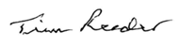
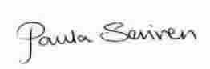

Paula Scriven and Tim Reeder
Co Chairs of Governors, Therfield School

